DATA STRUCTURES AND APPLICATIONS (18CS32)
SEMESTER – III
Course Learning Objectives:
This course (21CS32) will enable students to:
• Explain fundamentals of data structures and their applications essential for programming/problem solving
• Illustrate linear representation of data structures: Stack, Queues, Lists, Trees and Graphs
• Demonstrate sorting and searching algorithms
• Find suitable data structure during application development/Problem Solving
Module 1:Introduction: Data Structures, Classifications (Primitive & Non Primitive), Data structure Operations, Review of Arrays, Structures, Self-Referential Structures, and Unions. Pointers and Dynamic Memory Allocation Functions.Representation of Linear Arrays in Memory, Dynamically allocated arrays. Array Operations: Traversing, inserting, deleting, searching, and sorting. Multidimensional Arrays, Polynomials and Sparse Matrices. Strings: Basic Terminology, Storing, Operations and Pattern Matching algorithms. Programming Examples. Textbook 1: Chapter 1: 1.2, Chapter 2: 2.2 - 2.7 Text Textbook 2: Chapter 1: 1.1 - 1.4, Chapter 3: 3.1 - 3.3, 3.5, 3.7, Chapter 4: 4.1 - 4.9, 4.14 Reference 3:Chapter 1: 1.4 RBT: L1, L2, L3 10
Module 2Stacks: Definition, Stack Operations, Array Representation of Stacks, Stacks using Dynamic Arrays, Stack Applications: Polish notation, Infix to postfix conversion, evaluation of postfix expression. Recursion - Factorial, GCD, Fibonacci Sequence, Tower of Hanoi, Ackerman's function. Queues: Definition, Array Representation, Queue Operations, Circular Queues, Circular queues using Dynamic arrays, Dequeues, Priority Queues, A Mazing Problem. Multiple Stacks and Queues. Programming Examples.Textbook 1: Chapter 3: 3.1 -3.7 Textbook 2: Chapter 6: 6.1 -6.3, 6.5, 6.7-6.10, 6.12, 6.13 RBT: L1, L2, L3 10
Module 3 Linked Lists: Definition, Representation of linked lists in Memory, Memory allocation; Garbage Collection. Linked list operations: Traversing, Searching, Insertion, and Deletion. Doubly Linked lists, Circular linked lists, and header linked lists. Linked Stacks and Queues.10 Applications of Linked lists – Polynomials, Sparse matrix representation. Programming Examples Textbook 1: Chapter 4: 4.1 – 4.6, 4.8 Textbook 2: Chapter 5: 5.1 – 5.10 RBT: L1, L2, L3
Module 4 Trees: Terminology, Binary Trees, Properties of Binary trees, Array and linked Representation of Binary Trees, Binary Tree Traversals - Inorder, postorder, preorder; Additional Binary tree operations. Threaded binary trees, Binary Search Trees – Definition, Insertion, Deletion, Traversal, Searching, Application of Trees-Evaluation of Expression, Programming Examples Textbook 1: Chapter 5: 5.1 –5.5, 5.7 Textbook 2: Chapter 7: 7.1 – 7.9 RBT: L1, L2, L3 10
Module 5 Graphs: Definitions, Terminologies, Matrix and Adjacency List Representation Of Graphs, Elementary Graph operations, Traversal methods: Breadth First Search and Depth First Search. Sorting and Searching: Insertion Sort, Radix sort, Address Calculation Sort. Hashing: Hash Table organizations, Hashing Functions, Static and Dynamic Hashing. Files and Their Organization: Data Hierarchy, File Attributes, Text Files and Binary Files, Basic File Operations, File Organizations and Indexing Textbook 1: Chapter 6 : 6.1 –6.2, Chapter 7:7.2, Chapter 8 : 8.1-8.3 Textbook 2: Chapter 8 : 8.1 – 8.7, Chapter 9 : 9.1-9.3, 9.7, 9.9 Reference 2: Chapter 16 : 16.1 - 16.7 RBT: L1, L2, L3 10
Course Outcomes: The student will be able to :
• Use different types of data structures, operations and algorithms
• Apply searching and sorting operations on files
• Use stack, Queue, Lists, Trees and Graphs in problem solving
• Implement all data structures in a high-level language for problem solving.
Textbooks: 1. Ellis Horowitz and SartajSahni, Fundamentals of Data Structures in C, 2nd Ed, Universities Press, 2014. 2. Seymour Lipschutz, Data Structures Schaum's Outlines, Revised 1st Ed, McGraw Hill, 2014.
Reference Books:1. Gilberg&Forouzan, Data Structures: A Pseudo-code approach with C, 2nd Ed, Cengage Learning,2014 2. ReemaThareja, Data Structures using C, 3rd Ed, Oxford press, 2012.
3. Jean-Paul Tremblay & Paul G. Sorenson, An Introduction to Data Structures with Applications, 2 nd Ed, McGraw Hill, 2013 4. A M Tenenbaum, Data Structures using C, PHI, 1989
5. Robert Kruse, Data Structures and Program Design in C, 2nd Ed, PHI, 1996.

MODULE I- ARRAYS,STRUCTURES& STRINGS

- a) Define data Structure? List and Explain the Data structures operations.(5m)(Dec 2018/Jan 2019) b) Write the bubble sort algorithm(5m) c) List and explain in detail, the three types of structures used to store string .(10m)
- a) Explain Dynamic memory allocation(5m) )(Dec 2018/Jan 2019)
b) Explain about the representation of 2 Dimensional array in memory.(5m)
c)What do you meant by pattern Matching? Let P and T be the string with length R and S respectively and are stored as array with one character per element. Write a pattern matching algorithm that finds index P in T. Also discuss about this algorithm. (10 marks)
- Give ADT Sparse matrix and show with a suitable example sparse matrix representation storing as triples. Give search function to search for a key in triples and Give simple transpose function to transpose sparse matrix. (June 2013) (8 marks)
- How would you represent two sparse polynomials using array of structures and also write a function to add that polynomial and store the result in the same array. (June 2013) (December 2015) (6 marks)
- How would you represent two sparse polynomials using array of structures and also write a function to add that polynomial and store the result in the same array.
(June 2013) (December 2015) (6 marks)
- What is polynomial? What is the degree of the polynomial? Write a function to add two polynomails. (December 2013) (June 2015) (8 marks)
- Write a note on dynamically allocated arrays using example. (December 2015) (6 marks)
- Write knuth pattern matching algorithm and apply the same to search the pattern ‘abcdabcy’ in the text’abcxabcdabxabcdabcdabcy’ (8 Marks) Dec2016/Jan 2017
- Write the fast transpose algorithm for the sparse matrix. Why the name sparse matrix? (June 2014) (8 marks)
- Write the fast transpose algorithm for the given sparse matrix.Express the given sparse matrix as triplets and find its transpose 8 Marks) Dec2016/Jan 2017
10 0 0 25 0
0 23 0 0 45
A= 0 0 0 0 32
0 0 0 31 0
0 0 0 0 0
0 0 10 0 0

MODULE II- STACKS & QUEUES

- a) Define stack.Write the procedure for two basic operations associated with stack.(5m) Dec 2018/Jan 2019
b)Write a short note on priority queues(5m)
c)DefineRecursion.What are the properties of recursive procedure?Write recursive procedure for i)Tower of Hanoi ii)Factorial of a number.(10 M)
- a)Define queue.Write QINSERT and QDELETE procedures for queues using arrays.(10m)Dec 2018/Jan 2019
b. Write the postfix form of the following expression. A+(B*C/E^F)*G)*H.(5 m)
- Write the algorithm to implement stack using dynamically array whose initial capacity is 1 and array doubling is used to increase the stack’s capacity(that is dynamically reallocate twice the memory) whenever an element is added to a full stack. Implement the operation push,pop and display.(8 Marks) Dec2016/Jan 2017
- Write an algorithm for towers of Hanoi. (4 Marks) Dec2016/Jan 2017
- Write a note on Ackerman’s function. (4 Marks) Dec2016/Jan 2017&Dec 2018/Jan 2019
- List the disadvantages of linear queue and explain how is it solved by circular queue.Give the algorithm to implement the circular queue with suitable example.(8 Marks) Dec2016/Jan 2017
- Convert the infix expression ((a/(b-c+d))*(e-a)*c) to postfix expression. Write a function to evaluate the postfix expression and trace for the given data a=6,b=3,c=1,d=2,e=4.(8 Marks) Dec2016/Jan 2017
- What is a stack? Write an ADT for stack and list the applications of stacks. (6Marks) Jun2016/July 2016
- Write a C program to implement stack operations. 10Marks (Jun2016/July 2016 )
- What is recursion? Write the recursive C function for i) Finding a factorial (n).
- Fibonacci series.
- Tower of Hanoi.(8Marks) (Jun2016/July 2016 )
- What is a maze problem? Explain in detail.(8Marks) (Jun2016/July 2016 )
- Define queue. Explain the operations performed on queue.(8 Marks) Dec2015/Jan 2016
- What is circular queue? Write a C program to implement circular queues using dynamicarrays.(8 Marks) Dec2015/Jan 2016
- Explain multiple stacks and queues. (8Marks) (Jun2015/July 2015 )
- Explain stacks using dynamic arrays. (8Marks) (Jun2015/July 2015
- Write a C program to convert infix to postfix expressions. (8Marks) (Dec 2015/Jan 2016)
- Convert infix to postfix expression for the following i) ((a/b^c)*(d-e%f)) (4Marks) (Dec 2015/Jan 2016)
- Evaluate the following postfix expression ab*c-da+/ when a=2,b=3,c=1,d=4. (4Marks) (Dec 2015/Jan 2016)
- What is priority queue? Explain the various types of priority queue.(8 Marks)Jun-July 2013
- Write a program/procedure for a maze problem. (10 Marks)
- What is double ended queue? Explain with an example.(4 Marks)( Jun-July 2013)
- For the given circular queue shown in fig.1 ,write the values of front and rear in the table after each specified operation is performed Queue full/empty conditions must be considered.0-7 indicate the array indices. (10 Marks)Dec 2010
Operation | Rear | Front
Insert 0
Insert 10
Insert 15
Delete

22.

MODULE III-LINKED LISTS

- a. Write the following algorithm for singly linked list i)Inserting ITEM as the first node in the list ii)Deleting the node with the given ITEM of information(10m) Dec 2018/Jan 2019
b. Write the node structure for linked representation of polynomial. Write the function to add two polynomials represented using linked list.(10 m)
- a. Write the functions to perform the following i)Inverting a singly linked list ii) Concatenating the singly linked list iii)Finding the length of a circular list.(10 m)Dec 2018/Jan 2019
b. Write a note on header linked list.(5m)
c.For the given sparse matrix,Write the diagrammatic linked list representation.(5 m)
2 0 0 0
4 0 0 3
0 0 0 0
8 0 0 1
0 0 6 0
- Give the node structure to create a linked of integers and write C functions to perform the following:
a)Create a three node list with data 10,20 and 30.
b)Insert a node with data value 15 in between the nodes having data values 10 and 20.
c)Delete the node which is followed by a node whose data value is 20.
d)Display the resulting singly linked list.(10 Marks) Dec2016/Jan 2017
- Write a C function to implement the insert and delete operations on a queue using linked list.(10M) Dec2015/Jan 2016
- With node structure show how would you store the polynomials in linked list?Write C function for adding two polynomials represented as circular lists.(12 Marks) (Jun-July 2015)
- Write a short notes on :i)Linked representation of sparse matrix ii)Doubly linked list (10 Marks) m(Dec 2014-Jan 2015)
- What is linked list?Explain the different types of linked list with diagram.(10 Marks) (Dec 2013-Jan 2014).
- Write a function to insert a node at front end and rear end in a circular linked list.(10 Marks) (Dec 2013-Jan 2014).
- Describe doubly linked list with advantages and disadvantages. Write a C function to delete a node from a doubly linked list. Ptr is the pointer which points to the node to be deleted.(12 Marks) (Dec 2012-Jan 2013).
- Write a C program to perform the following operation on doubly linked list.
i)Insert a node ii) Delete a node (10 Marks) (Jun-July 2012)
- Explain array is used in implementing a linked list. (10 Marks) (Jun-July 2012)
- Explain about garbage collection and sparse matrix multiplication(14 Marks) (Jun-July 2017)

MODULE IV -TREES
- a. What is a tree? Write the routines to traverse the given string using i) Pre-Order traversal ii)In-order traversal iii)Post-Order traversal.(10m)Dec 2018/Jan 2019
b. Define Binary search tree. Write the recursive search and iterative search algorithm for a binary search tree (10m)
- a. Write the routines for i) Copying binary trees ii)Testing for equality of binary trees.(10m)Dec 2018/Jan 2019
b. List the rules to construct the threads. Write the routines for in order traversal of a threaded binary tree(10m)
- What is binary tree? State its properties. How is it represented using arrays and linked lists? Give example. (10 Marks)Dec 2011
- Show the binary tree with the arithmetic expression A/B*C*D +E. Give the algorithm for inorder, preorder and postorder traversals and show the result of these traversals.(8 Marks) (Jun-July 2015)
- Define binary search tree. Draw the binary search tree for the following input 14,15,4,9,7,18,3,5,16,4,20,17,9,14,5.(10 Marks) Dec 2013
Constuct the binary tree having the following sequences: (10 Marks)Dec 2012
i)Preorder sequence ABCDEFGHI
ii)Inorder sequence BCAEDGHFI
- Write an iterative search routine for a BST. (10 Marks)Dec 2014
- Define a binary tree and with example show array representation and linked representation of binary tree. .(8 Marks) (Jun-July 2015)
.Construct a binary search tree with elements (22,28,20,25,22,15,18,10,14}.Give recursive search algorithm to search an element in that tree. (8 Marks) (Jun-July 2016)
- Draw a binary search tree for the following input. 14,5,6,2,18,20,16,18,-1,21 (10 Marks)Dec 2012
- Define binary trees.For the given tree find the following.
Leaf nodes iii)Non leaf nodes iV)Ancestors V)Level of trees
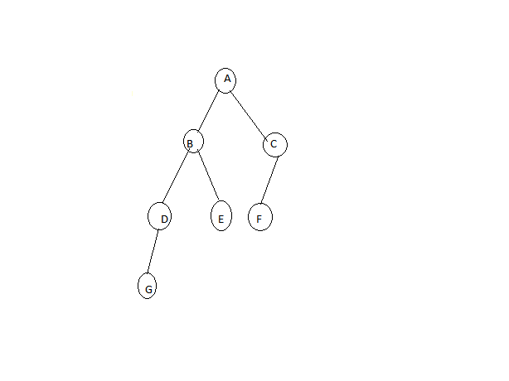
- Write the C-routines to traverse the tree using i)inorder ii)preorder iii)postorder(8 Marks) Dec2016/Jan 2017
- Write an algorithm to arrange a given list of numbers into a BST.
- Define the following i) Strictly binary tree ii) Complete binary tree iv) Almost Complete binary tree
- What is BST? Construct a binary search tree for the following list of integers. 8, 13, 10,12,6,5,12
- Constuct a binary tree for the following expressions: (jun/july 2012)
i)A+(B-C)*(E+F)/G
ii) (5+6+*7)$((5+6)*7)
- What do you mean by traversal? Construct a binary tree and traverse the same in preorder,inorder and postorder for 25,10,13,40,9,31,5,1,100,75.(10 Marks) (jun/july 2017)
- Write the following C functions for,
i) Counting the number of leaf nodes in a binary tree.
ii) Finding the in order successor of a node in a threaded binary tree. (10 Marks)(Dec 09/Jan 2010)
- Describe BST with an example .Write an iterative function to search for a key value in a binary search tree. (10 Marks) (Dec 09/Jan 2010)
- 18.What is tree?With suitable example define i)Binary tree ii)Level of binare tree iii)Complete binary tree (8 Marks) Dec2016/Jan 2017
- 19.What is binary search tree?Write algorithm to implement for recursive search or oterativi search for a binary search tree. (8 Marks) Dec2016/Jan 2017
- 20.Write a routinesfor i) Create s binary tree ii)Testing for equality of binary tree. (8 Marks) Dec2016/Jan 2017

MODULE V-GRAPHS,HASHING& FILES
(Expected Questions-New syllabus)
- a. Write an algorithm for an insertion sort.Also discuss about the complexity of insertion sort.(10 m)Dec 2018/Jan 2019
b. Write an algorithm for i)Breadth first search ii)Depth first search(10 m)
- a. Define graph. Explain in detail about directed graphs.(10m)Dec 2018/Jan 2019
b. Explain in detail about static and dynamic hashing.(10m)
- Define graph. What are the types of graph? Explain with diagram.
- Give the adjacency matrix & adjacency list representation for the graph shown in fig.
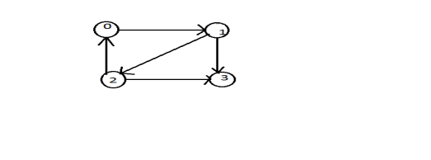
- Explain different representation of graphs with an appropriate examples.
- Explain the following traversal methods. I)BFS ii)DFS
- Define DFS & BFS graph.Show DFS and BFS for the graph given below and draw the spanning tree.
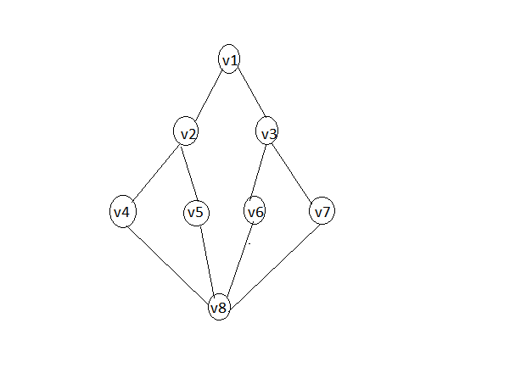
- .For the following graph construct the following and consider Source is 1.
A)Adjacency matrix
B)Adjacency list
C)DFS search
D)BFS search
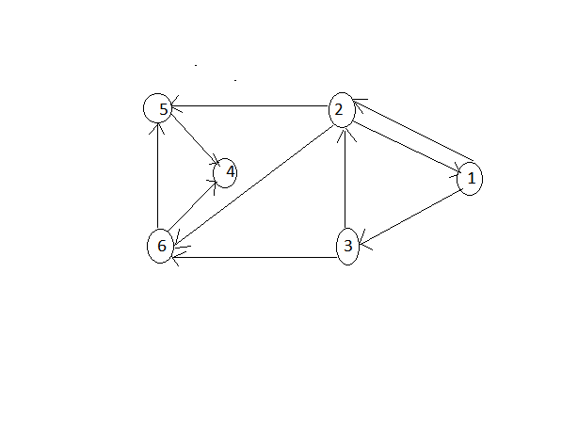
- List the differences between DFS & BFS.
- Define the following:i)Hashing ii)Hash Table iii)Hash functions
- Explain the types of hash function with an appropriate example.
- What are the different types of hashing? Explain in detail.
- What is collision? Explain any two collision resolution techniques.
- Explain the following: Linear probing & Double hashing.
- Explain the applications of hashing.
- Explain indexing in detail.
- Explain directoryless dynamic hashing(5 Marks) Dec2016/Jan 2017
- Explain open addressing and chaining used to handle overflows in hashing(5 Marks) Dec2016/Jan 2017

